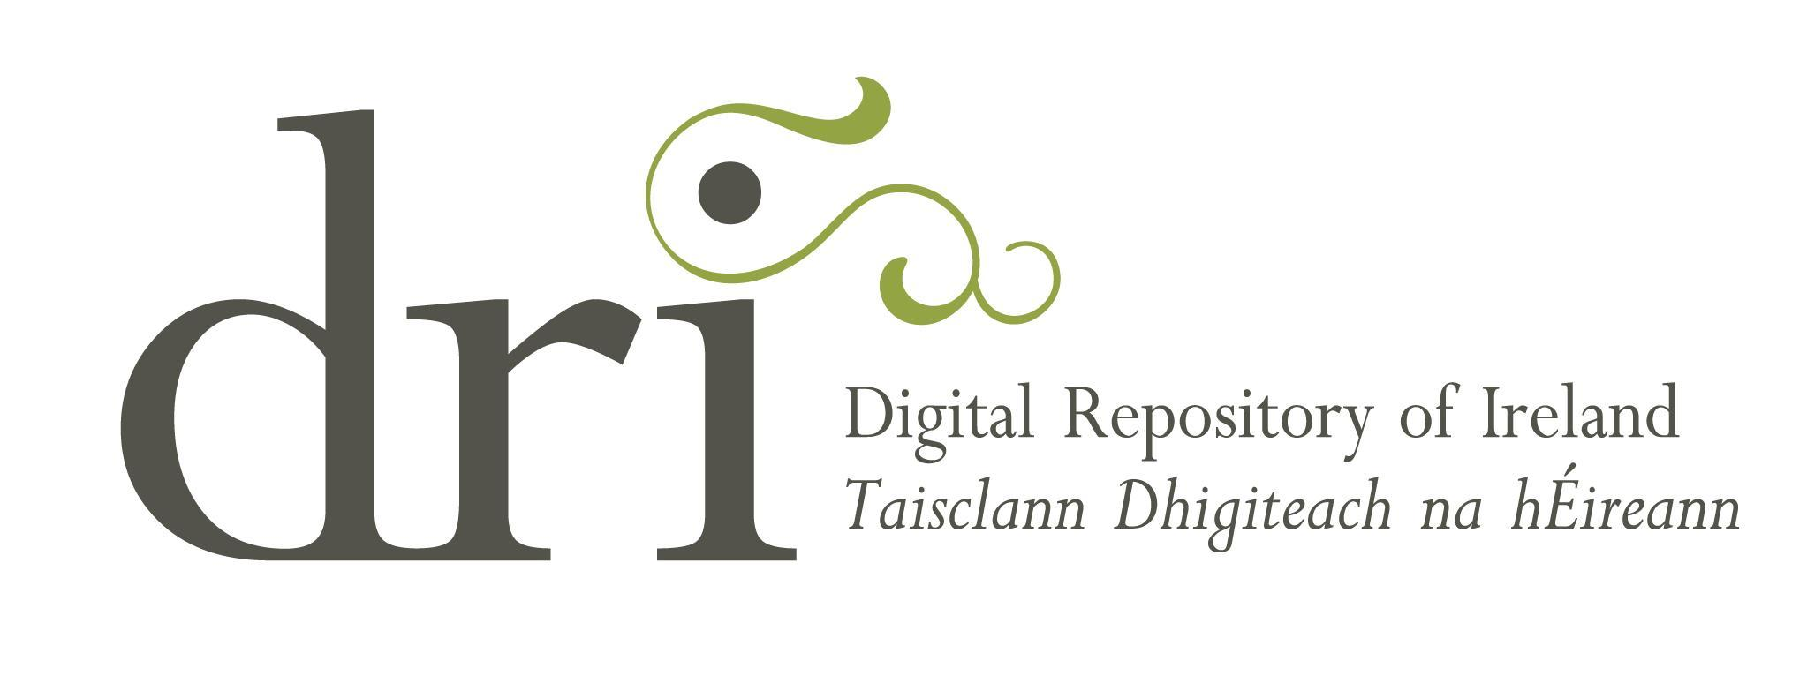

# Digital Repository of Ireland

# Community Archive Scheme 2025

# **Application Form**

### Closing date: 8 November 2024

# About the DRI Community Archive Scheme

Community archives aim to give visibility to the stories and histories of specific cultures and communities that are often underrepresented in national or regional archives. These archives are typically created by individuals or groups working on a voluntary basis or with little funding.

As a publicly funded repository for Ireland’s social and cultural data, the Digital Repository of Ireland (DRI) believes it is important to make long-term preservation of digital materials open to a wide range of organisations, including those operating on a non-funded, voluntary basis.

We value the publication of a diversity of datasets and collections and are committed to supporting community-based archival initiatives through sharing our digital preservation skills and profession-based knowledge. We, therefore, offer free memberships, and all the related benefits, as part of our DRI Community Archive Scheme.

DRI Membership under the DRI Community Archive Scheme is offered for the period it takes to ingest one collection (see benefits aligned with ‘Associate’ level membership on our DRI Membership page: <https://dri.ie/membership>).

# Information session about the scheme

DRI is launching the Community Archive Scheme on 28 August 2024. Please register here.

We will also host one 45 minute online information session on the following date:

* Wednesday 25 September at 2pm

This session will be recorded and placed on our website, [www.dri.ie](http://www.dri.ie). In the information session we will talk informally to any community group that may be interested in applying for the Community Archive scheme. We will explain the benefits of the scheme, how to apply and how applications are judged.

[We ask that you please register in advance for this meeting](https://ria-ie.zoom.us/meeting/register/tZcod-6gpz0oHNy29UD-jBY-mMCYKZuP15qW#/registration). After registering, you will receive a confirmation email containing information about joining the meeting.

For more information on the DRI Community Archive Scheme, please visit our dedicated webpage: <https://www.dri.ie/dri-community-archive-scheme>

If you have any further questions please email [members@dri.ie](mailto:memebrs@dri.ie).

### Important Dates to Note:

Opening date for the DRI Community Archive Scheme: **28 August 2024**

Information session: **2.00pm, 25 September 2024**

Closing date for applications: **5.00pm, 8 November 2024**

# This application is broken into three sections:

1. Overview of Applicant Organisation and Proposed Collection (the details we would like you to provide us with).
2. Eligibility criteria (information we ask you to provide us so that we can assess if you are eligible for the award).
3. Additional information (information about DRI that it might be helpful for you to know).

# 1. Overview of Applicant Organisation and Proposed Collection

Organisations from anywhere on the island of Ireland, or international organisations with digital material relevant to Ireland, are welcome to apply for the DRI Community Archive Scheme. Please provide details about your organisation under the headings below.

Organisation name:

|  |
| --- |
|  |

Organisation contact address:

|  |
| --- |
|  |

Organisation website link:

|  |
| --- |
|  |

Please provide a brief description of your organisation (e.g., your organisation’s mission or remit) (200-500 words):

|  |
| --- |
|  |

Please provide a brief description of the collection material you would like to ingest in DRI (e.g., is the collection material of cultural or artistic interest and/or of interest to humanities and social sciences researchers) (200-500 words):

|  |
| --- |
|  |

# 2. Eligibility Criteria

Please provide answers to the questions below to confirm your eligibility for the DRI Community Archive Scheme.

**Question 1:** To be eligible for the DRI Community Archive Scheme, organisations must operate on low or no income; for example, community groups, civil society organisations, or charities/non-profits that are operated by volunteers. Please provide details of your organisational funding. If your organisation is not in receipt of any funding, please state this in your response.

|  |
| --- |
|  |

**Question 2:** As part of the DRI Community Archive Scheme benefits, we offer free digital preservation training covering areas such as collection appraisal, licensing and copyright, metadata preparation, and the DRI ingest and publication process. Our introductory training course takes approximately one to two hours to complete. If further support is required, we offer a bespoke Community Archives Training Course. This course consists of one hour-long session per week over a period of eight weeks. Will somebody within your organisation be able to commit to undertaking training?

|  |
| --- |
|  |

**Question 3:** Receipt of free DRI Membership as part of the DRI Community Archive Scheme is conditional upon the organisation ingesting one collection. DRI staff will provide help and support, but organisations should be able to commit at least one volunteer/member to take on the task of preparing materials for ingest, active ingest, and creating metadata. Please indicate if you will be able to commit to preparing metadata and ingesting content within the first year of membership. Please provide an approximate time commitment, if possible.

|  |  |
| --- | --- |
| **YES** |  |
| **NO** |  |

|  |
| --- |
| Timeframe: |

**Question 4:** To be eligible for the DRI Community Archive Scheme, the material from your collection(s) should be suitable for Open Access publishing (e.g. all objects intended for ingestion must have a rights statement and some form of reuse licence). For more information on licensing and Open Access, see [DRI’s Factsheet on Copyright, Licensing and Open Access](https://repository.dri.ie/catalog/rb699s72v). Please confirm if your material is suitable for Open Access publishing (material, where the rights holder is unknown, would not be suitable).

|  |  |
| --- | --- |
| **SUITABLE** |  |
| **UNSUITABLE** |  |

**Question 5:** Please provide an overview/inventory of digital content you have identified that may be suitable for ingest, including the volume of the content, file formats, and current metadata accompanying the content.

1. Approximate number of collection items:

|  |
| --- |
|  |

1. File Formats (e.g., textual [PDFa, rtf, txt, xml, PDF, DOC, DOCx], audio [WAV, BMAV, PM3, MP2], image [TIFF, JPEG]):

|  |
| --- |
|  |

1. Sample Metadata (see ‘Additional Information for Applicants’ section below)

|  |
| --- |
|  |

# Additional Information for Applicants

**Metadata:**

DRI uses metadata (often described as ‘data about data’) to enhance content searchability, discoverability and support overall data management. (For more information on Metadata, please see our Metadata and the DRI Factsheet: <https://doi.org/10.7486/DRI.bz60sj10d>) Metadata that accompanies uploaded material will be published on the DRI with a [CC BY licence](https://creativecommons.org/about/cclicenses/).

**Europeana:**

DRI is an accredited National Aggregator for [Europeana](https://www.europeana.eu/e), and an active member of the [Europena Aggregators’ Forum](https://pro.europeana.eu/page/aggregators). As such, we support the aggregation of Irish digital cultural heritage content to the Europeana collections platform, which provides a centralised search and discovery portal for content from European Cultural Heritage Institutes, and makes Irish content accessible to a wider European audience. Should the winning organisation wish for their material to be aggregated to Europeana, the metadata will be published there with a [CC0 licence](https://creativecommons.org/share-your-work/public-domain/cc0/).

**Helpful Resources:**

Digital Repository of Ireland. DRI Factsheet No. 1: Metadata and the DRI V2, Digital Repository of Ireland [Distributor], Digital Repository of Ireland [Depositing Institution], <https://doi.org/10.7486/DRI.bz60sj10d>

Digital Repository of Ireland. DRI Factsheet No 2: Copyright, Licensing and Open Access, Digital Repository of Ireland [Distributor], Digital Repository of Ireland [Depositing Institution], <https://doi.org/10.7486/DRI.rb699s72v>

Digital Repository of Ireland. DRI Factsheet No 3: File formats (2015-2018), Digital Repository of Ireland [Distributor], Digital Repository of Ireland [Depositing Institution], <https://doi.org/10.7486/DRI.rj43ck402-1>

Digital Repository of Ireland. Introductory training and repository walkthrough, Digital Repository of Ireland [Distributor], Digital Repository of Ireland [Depositing Institution], <https://doi.org/10.7486/DRI.rj43ct08r>

For more information on the DRI Community Archive Scheme and to download the application form please visit our dedicated webpage: <https://www.dri.ie/dri-community-archive-scheme>

If you have any further questions please email [members@dri.ie](mailto:memebrs@dri.ie)